**About us**

Aeromaps Consultancy Ltd is a firm registered in Kenya to offer environmental, health and safety consultancy services. Our team comprises of experts in various disciplines including: engineers; environmental specialists; geographers and GIS experts; enforcement and regulatory specialists. Our commitment to our customers is to deliver value through technical excellence, professionalism, timely delivery, and trust. Our dedication to building mutual relationships through participatory problem identification and solution implementation defines us.

**Our Values**

1. Technical Excellence
2. Professionalism
3. Trust and integrity
4. Partnership
5. Customer satisfaction

**Our Vision**

**To XXX**

**Our Mission**

**To XXX**

**Our clients**

**Home Page Slide show Photos**

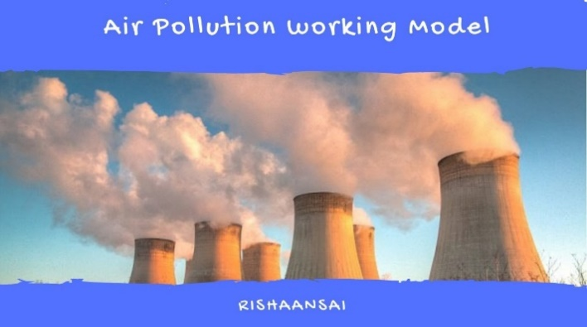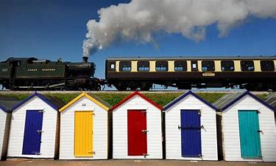

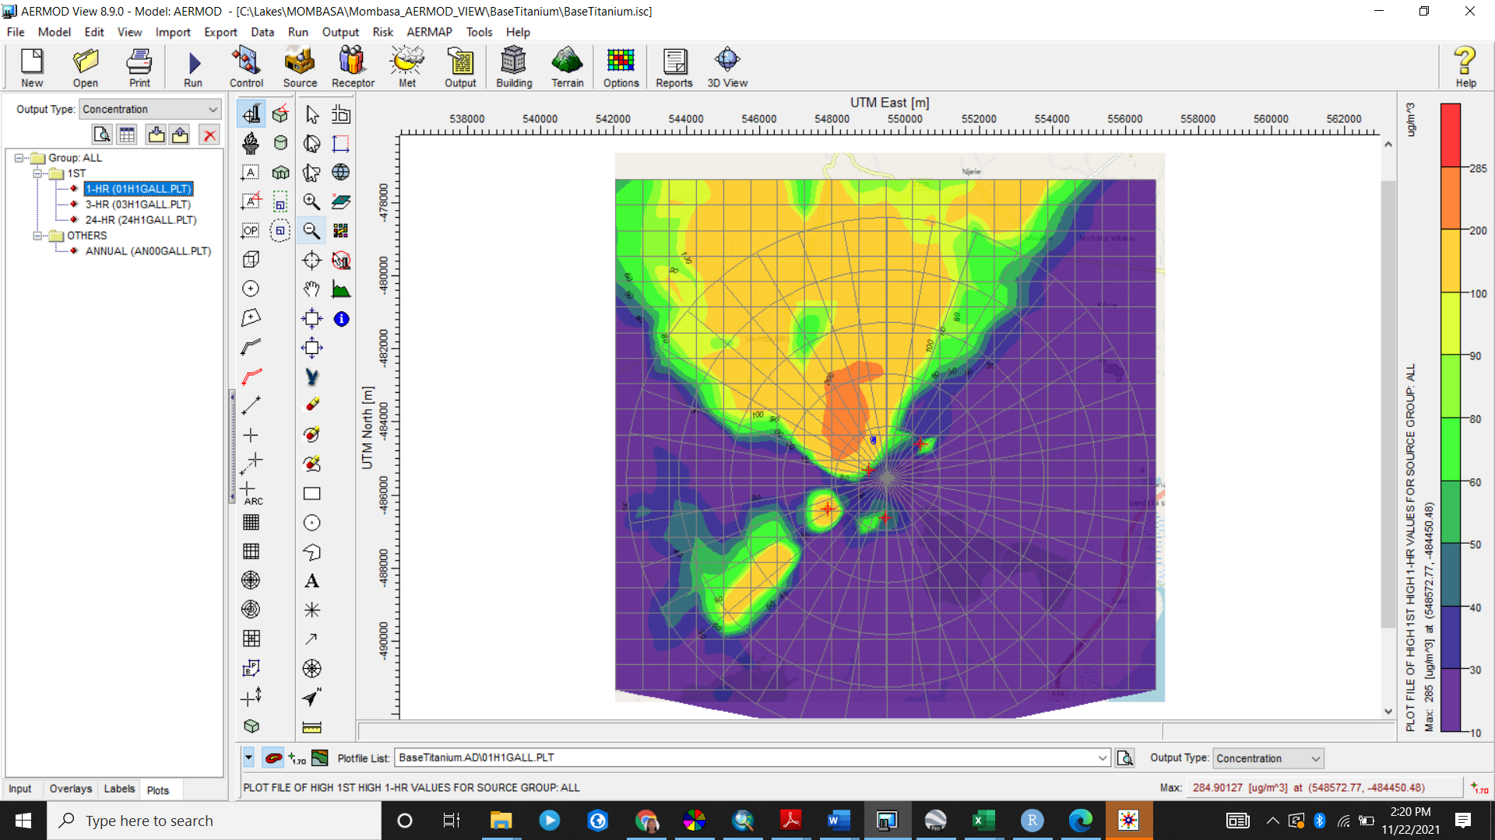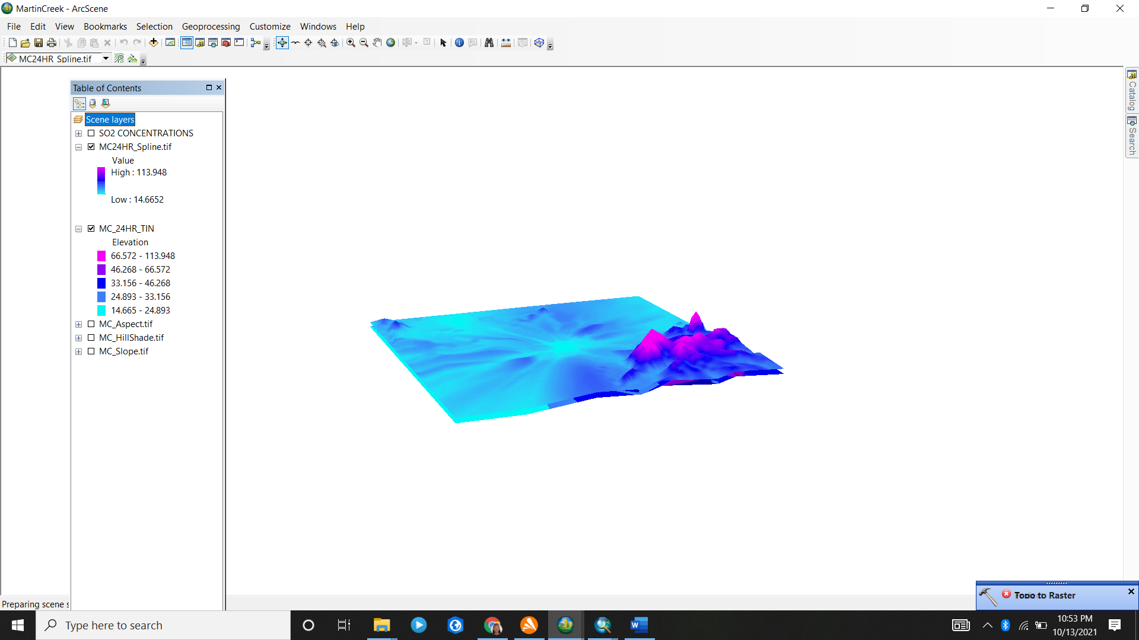

**Our clients**

We serve clients from diverse sectors:

1. Power
2. Energy
3. Mining
4. Industrial
5. Infrastructure

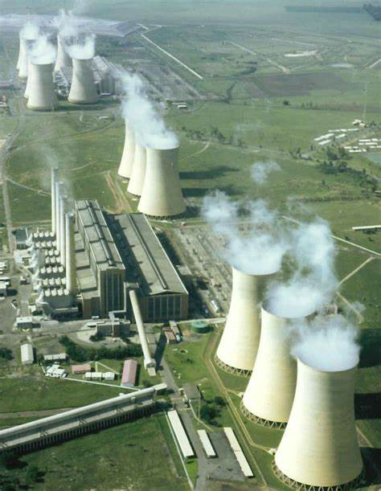 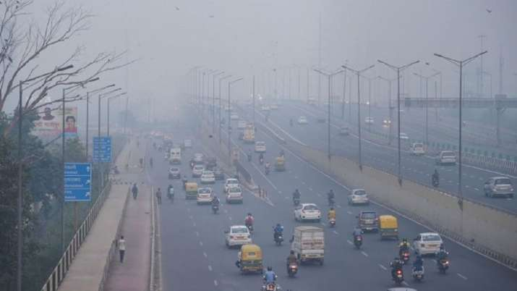

Energy

Infrastructure

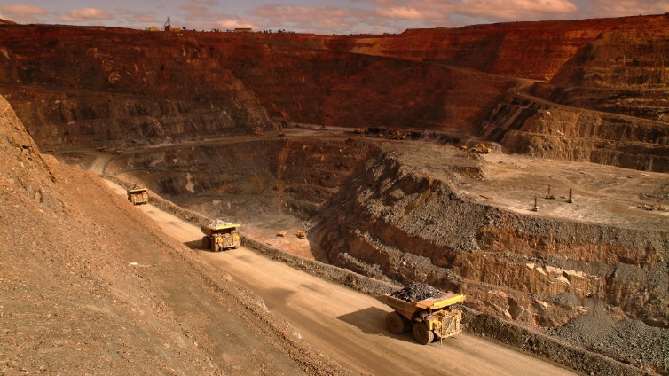

Mining

**Core values**

1. Technical Excellence
2. Professionalism
3. Trust and integrity
4. Partnership
5. Customer satisfaction

**Services offered**

**Air dispersion modelling**

Air dispersion and noise modellin

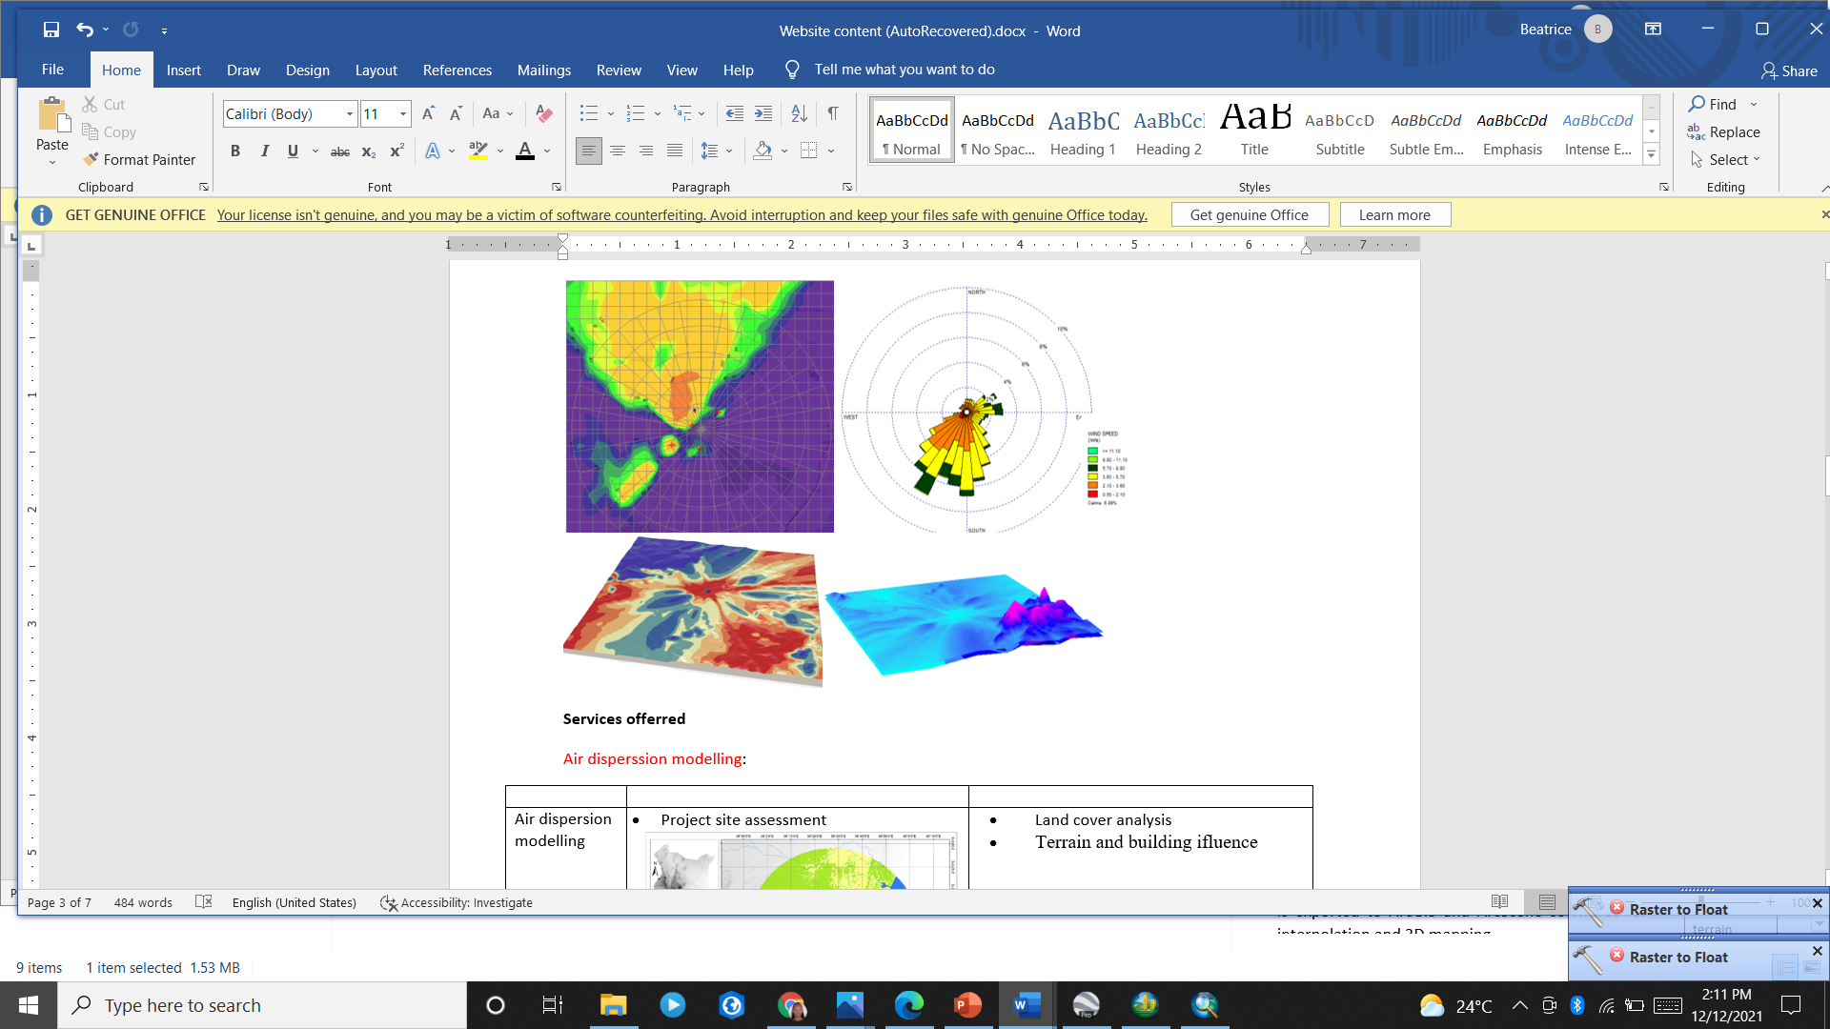

Our services involve:

* Project site assessment
* Land cover analysis
* Terrain and building influence
* Air dispersion and noise modelling
* Mapping model output
* Measurement and monitoring of temporal air emissions

**Geographic Information Systems for resource mapping and Planning**



Environmental challenges are location-oriented thus the need to offering spatially explicit solutions to address them. Some of our services include:

* Spatial data capture and development of databases
* Spatial data analysis and visualization (mapping)
* Spatial-temporal modelling
* Land cover classification and analysis
* Remote sensing

**Environmental and Social Impact Assessment and Audits**

**planning**

* Environmental impact assessments
* Writing EIA technical reports
* Conduct environmental audits